Nama : Putri Dwinatryska A.R.F

NIM : 21091397075

Kelas : A

# Latihan Soal Praktikum 4

**1. Input**

#include <iostream> using namespace std; struct node{ int data; node *next;

};

int main() {

node *n; node *t; node *h; node *bantu;

n= new node; n->data=2; t=n; h=n;

n= new node; n->data=5; t->next=n; t=t->next;

n= new node; n->data=8; n->next=NULL; t->next=n; bantu=n;

n= new node; n->data=7; t->next=n; n->next=bantu; t=h;

while( t!= NULL ){ cout << "Data : " << t->data <<endl; t = t->next;

}

return 0;

}

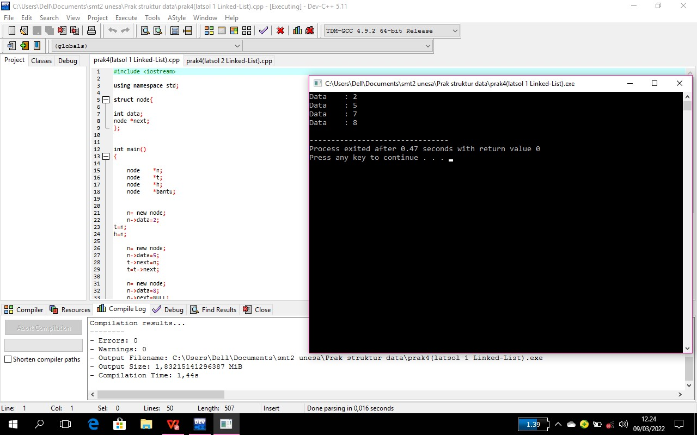

## Output

Data : 2

Data : 5

Data : 7

Data : 8